**Name – Ankesh Mobar**

Lab 1.

**Experiment no 1: WAP to take check if the triangle is valid or not. If the validity is established, do check if the triangle is isosceles, equilateral, right angle, or scalene. Take sides of the triangle as input from a user.**

Coding

#include<stdio.h>

int main()

{

int a, b, c;

printf("Enter sides of triangle:");

scanf("%d%d%d",&a,&b,&c);

if ((a+b>c) && (b+c>a) && (c+a>b)){

printf("It is a Valid Triangle\n");

if(a == b && b == c)

printf("The Given Triangle is equilateral\n");

else if(a == b || b == c || c == a)

printf("The given Triangle is isosceles\n");

else

printf("The given Triangle is scalene\n");

}

else{printf(" It is an invalid Triangle");

}

return 0;

}

**Output**

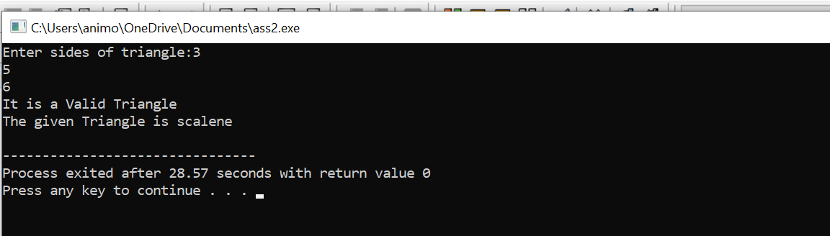

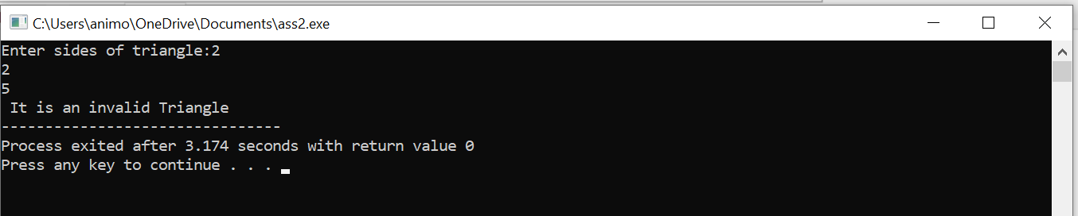

**Experiment no 2: WAP to compute the BMI Index of the person and print the BMI values as per the following ranges. You can use the following formula to compute BMI= weight(kgs)/Height(Mts)*Height(Mts).**

**Coding**

#include<stdio.h>

void main(){

float bmi,weight,height;

printf("enter weight in kg and height in m");

scanf("%f %f",&weight,&height);

bmi=weight/(height *height);

if(bmi<15){

printf("starvation");

}

else if(bmi>=15.1&&bmi<=17.5){

printf("anorexic");

}

else if(bmi>=17.6&&bmi<=18.5){

printf("underweight");

}

else if(bmi>=18.6&&bmi<=24.9){

printf("ideal");

}

else if(bmi>=25&&bmi<=25.9){

printf("overweight");

}

else if(bmi>=30&&bmi<=39.9){

printf("obese");

}

else if(bmi>40){

printf("mostly obese");

} else

{

printf("error");

}

}

**Output**

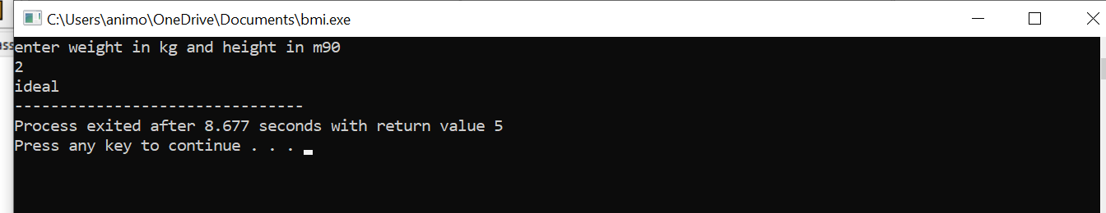

**Experiment no 3: WAP to check if three points (x1,y1), (x2,y2) and (x3,y3) are collinear or not.**

**Coding**

#include<stdio.h>

void main(){

int y2,y1,x2,x1,y3,x3;

printf("enter the coodinates");

scanf("%d %d %d %d %d %d",&x1,&y1,&x2,&y2,&x3,&y3);

int m=(y2-y1)/(x2-x1);

int m2=(y3-y2)/(x3-x2);

if(m==m2){

printf("colinear");

}

else

{

printf("non colinear");

}

}

**Output**

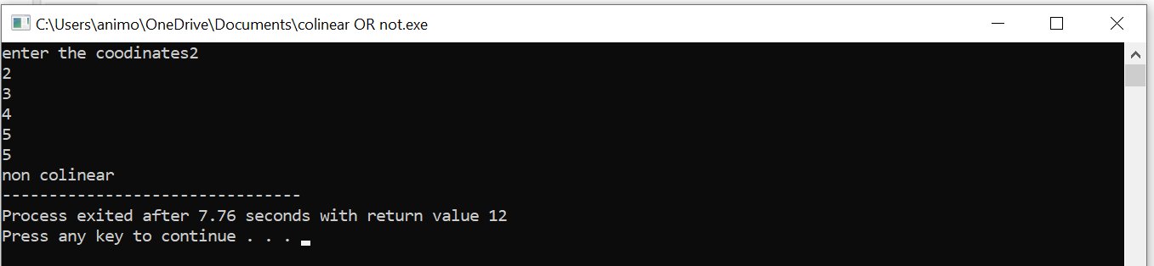

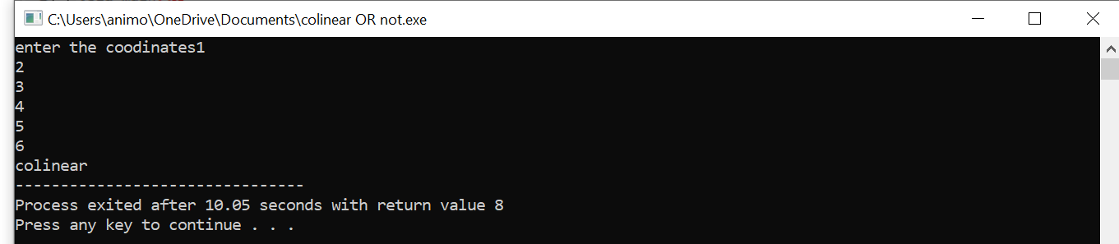

**Experiment No 4: According to the gregorian calendar, it was Monday on the date 01/01/01. If Any year is input through the keyboard write a program to find out what is the day on 1st January of this year.**

**Coding**

#include<stdio.h>

int main()

{

int year, basicyear=2000, leapyear, remainingyear, totaldays, day;

printf("Please enter the year: ");

scanf("%d",&year);

year= (year-1)-basicyear;

leapyear=year/4;

remainingyear= year-leapyear;

totaldays=(remainingyear*365)+(leapyear*366)+1;

day=totaldays%7;

if(day==0)

printf("Monday");

else if(day==1)

printf("Tuesday");

else if (day==2)

printf("Wednesday");

else if (day==3)

printf("Thusday");

else if(day==4)

printf("Friday");

else if(day==5)

printf("Saturday");

else if (day==6)

printf("Sunday");

else

printf("Wrong entry");

return 0;

}

Output

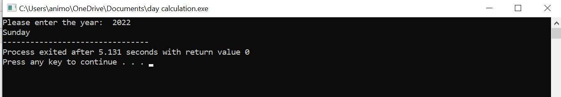

**Experiment 5: WAP using ternary operator, the user should input the length and breadth of a rectangle, one has to find out which rectangle has the highest perimeter. The minimum number of rectangles should be three.**

**Coding**

#include<stdio.h>

int main(){

int l1,l2,l3,w1,w2,w3,peri1,peri2,peri3;

printf("please enter the three conjugative length and width of rectangles\n");

scanf("%d%d%d%d%d%d", &l1, &l2, &l3, &w1, &w2, &w3);

peri1=2*(l1+w1);

peri2=2*(l2+w2);

peri3=2*(l3+w3);

peri1>peri2?peri1>peri3?printf("First retangle has largest perimeter"):printf("Third retangle has largest perimeter"):peri2>peri3?printf("Second rectangle has largest perimeter"):printf("Third rectangle has largest perimeter");

return 0;

}

**Output**

